Coding problem – OrgChart – Instructions

Write a Python software for reporting some company data.

Here is the example of company departments orgchart in the form of a tree.

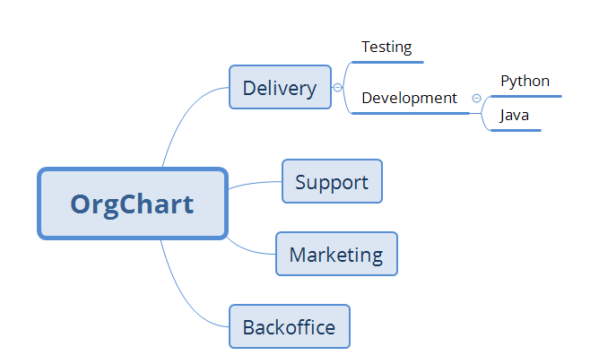

**company orgchart data file - example**

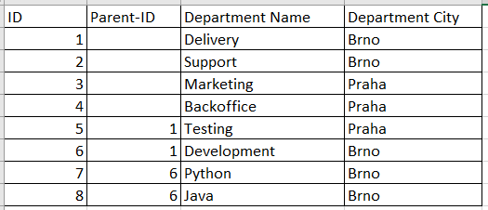

**employees data file - example**

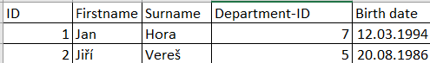

The program will take two input arguments = two files.

* First file contains company orgchart data
* Second file contains employees data

**$ python orgchart.py orgchart-data.csv employees-data.csv**

It will load the data from two files into a memory

It will wait in a loop for user input commands and it will display corresponding results.

Following commands should be supported.

**Command 1** – Display the department name and the city for given department ID

User command: **Department 5**

Output example: Testing, Praha

**Command 2** – Number of all employees for department INCLUDING all employees for department INCLUDING all its sub-departments (all levels, for example for Delivery it includes also Development, Python, Java) - for given department ID

User command: **Count 1**

Output example: 25

**Command 3** – List of names of all employees for department INCLUDING all its sub-departments (all levels, for example for Delivery it includes also Development, Python, Java) - for given department ID

User command: **People 1**

Output example: Jan Hora, Jiří Vereš

**Command 4** – Average age of all employees for department INCLUDING all its sub-departments (all levels, for example for Delivery it includes also Development, Python, Java) - for given department ID

User command: **Avgage 1**

Output example: 28 years

**Other instructions:**

* OOP approach will be aprreciated as well as good development practices and patterns
* Error checks will be aprreciated (file doesn’t exist, invalid file format, invalid command or argument)
* We will test it not only with the two files provided as example but also with other files
* Basicaly whatever can prove us that you are great developer will be aprreciated ☺

**Good luck from ThreatMark!**